**PHOTO VOLTAIC (PV) SOLAR PANEL MODELLING**

ENGN 8120 Systems Modelling

***Submitted by***

Peratchi Hariharasudhan Kannan U6366102

Table of Contents

1 Variable Selection 1

2 Model Development 1

3 Instantaneous power generation on equinox in Canberra 2

4 Energy generated on Equinox 3

5 Estimation of energy needs 3

6 Variables to be considered for cloudy conditions 3

7 Appendix 4

8 References 6

**List of Figures**

Fig 1 Hourly Power graph on equinox 2

Fig 2 Overall Power generation 2

1. Variable Selection

The most preferred choices of variables are the irradiance (G), temperature (T), photocurrent (Iph), reverse saturation current (Irs), open circuit voltage (Voc), short circuit current (Isc). The choices remain obvious, as these are the basic parameter are to be considered when designing any electrical based system. The generation of power primarily depends on irradiance, temperature and location (latitude). The photocurrent is the current generated in a cell, short circuit current / open circuit voltage is determined to ensure the rating of protective circuits for the PV model.

1. Model Development

The solar photovoltaic model is developed based on the following equations [1],

A single photovoltaic cell generates 0.6 V and a module contains 36 such cells connected in series to generate 21.6 V. In layman terms, the tilt angle of the photovoltaics is the latitude of the location where the panel is installed. This note can be elaborated as, Latitude angle + 15 (winter tilt) / Latitude angle – 15 (summer tilt). Other way to calculate tilt angle would be (latitude angle * 0.9) + 29 (winter tilt), this steeper tilt enables the panels to tap into more energy during the midday of short winter days. (Latitude angle *0.9) -23.5 (summer tilt) and latitude angle -2.5 (spring/ autumn tilts), these angles are highly helpful when the panels are mounted to a stand/ post rather than roof of the building. All the solar panels must be north facing in Australia to tap highest amount of energy. The tilt angle matters in the power generation because the irradiance/ insolation depends the incident angle of the light energy from the source.

$$H_{0h}=\frac{24}{π} I_{sc} 1+0.034\cos{\frac{2πn}{365.25}}\cos{φ}\cos{δ}\sin{ω_{s}}+\cos{ω_{s}}\sin{φ}\sin{δ}$$ The above equation [1-3] gives the amount of energy in Whm-2 on the horizontal earth surface at a latitude.

$$\cos{ω_{s}}= -\tan{δ}\tan{φ}$$ $φ-observer^{'}s latitude ; δ-declination angle$

The H0h equation gives the energy that incidents on earth on any day in 1m2, from which the irradiance can be calculated and fed into the model including temperature, to get the graph of maximum power generated on any given day.

1. **Instantaneous power generation on equinox in Canberra**

In Fig 1, the plot describes the hourly power generation throughout the equinox. Fig 2 (from Simulink model) clearly signifies the efficiency of the system which is around 13% (maximum power point) for the whole day of power generation (1m2 panel)

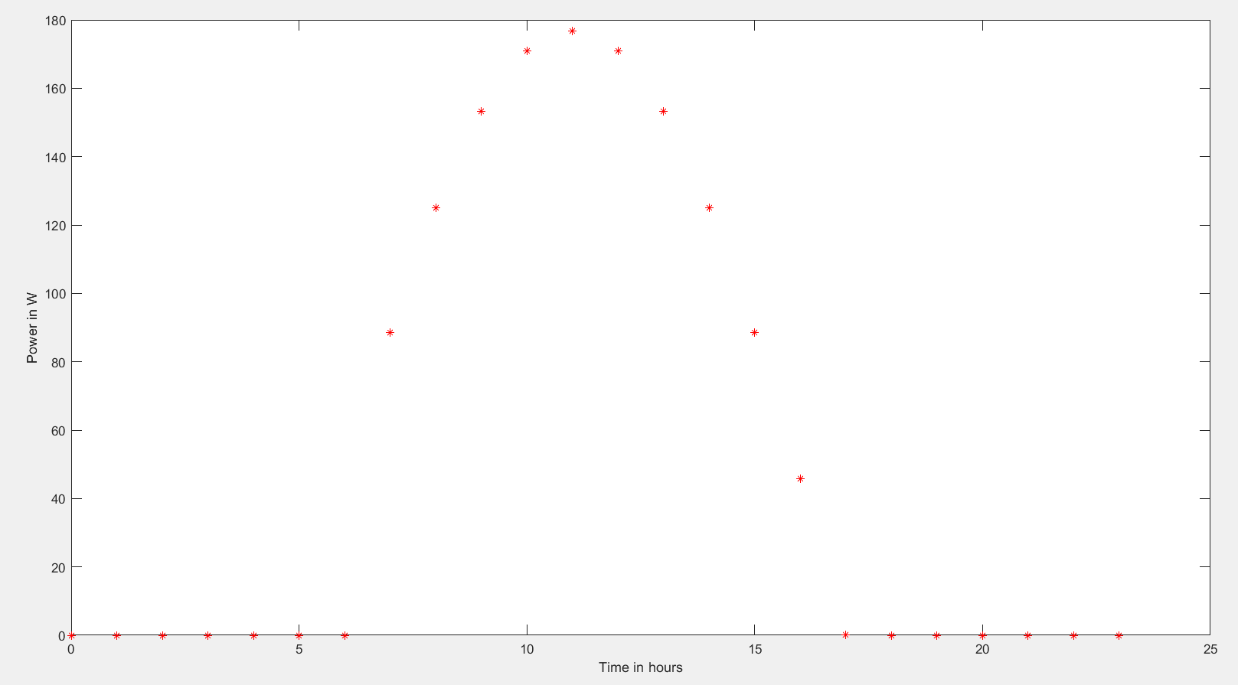

Fig 1 Hourly Power graph on equinox

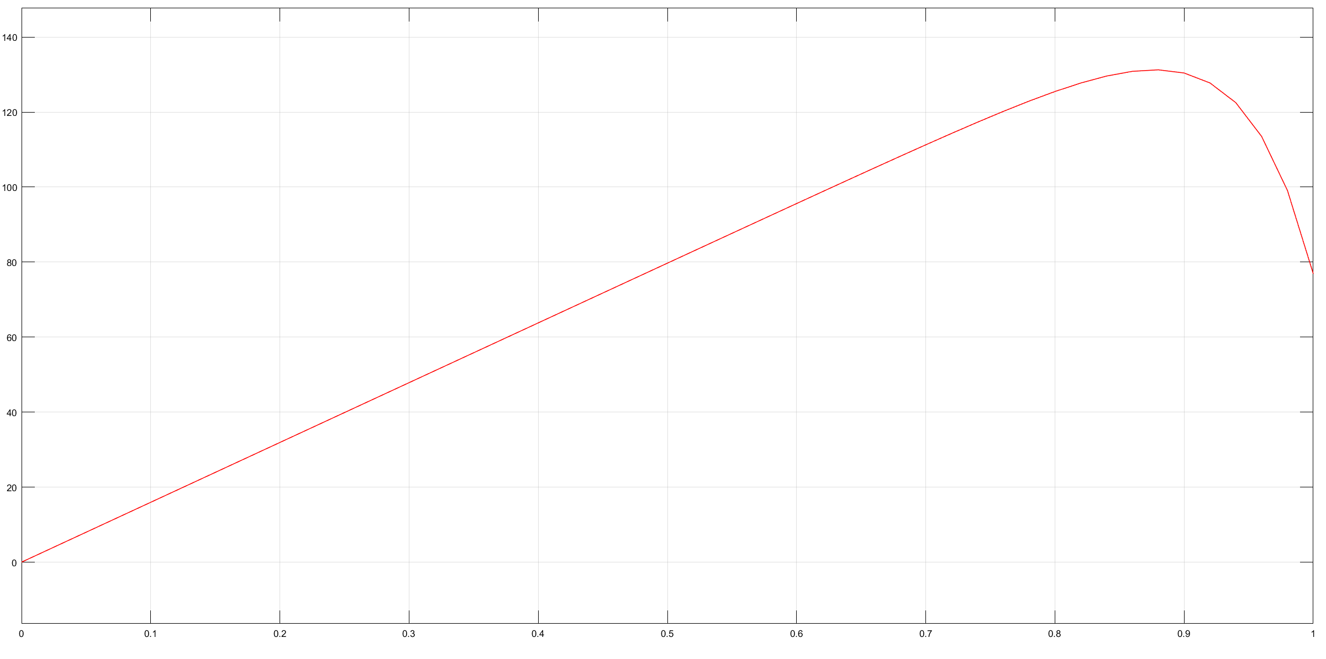

Fig 2 Overall Power generation

1. Energy generated on Equinox

Energy generated on equinox is given by total power * total time of power generation.

Total power = 1297.8 watts

Total Energy = 1297.8 * 12 (approximately)

= 15.573 kWh (assuming that 2 panels of 1m x 0.5m are connected)

1. Estimation of energy needs

Given: Energy need = 7500 kWh/year.

Number of hours in a year = 8765.8127

Power required for a year = Energy need / Number of hours in a year

= 7500/8765.812 = 856 watts (approximately) demanded per hour

Total power = Area of solar panel * Nominal irradiance * conversion efficiency

**Case 1** If the household plans to use solar energy during day/night time alone

Total power demand = 856 * 12 = 10272 watts

10272 = Area of solar panel * 1000 * 0.13

Area of solar panel = 7.9015 m2

**Case 2** If the household plans to use solar energy alone

Total power demand = 856 * 24 = 20544 watts

Area of solar panel = 15.80 m2

The above calculations were based on nominal conditions and assuming that the solar panel laid flat on the ground / roof and constant load demands. Area required can be reduced if the power is generated from tilted / maximum power point tracking panels

1. Variables to be considered for cloudy conditions

Solar irradiance variation, frequency/rate of weather change needs to be considered while modelling solar panel for cloudy conditions [2]. Typically, there will be a drop of 25 – 40% in power generation on a cloudy day.

1. Appendix

clear variables

clc

close all

trise = 6; % sunrise time in 24 hour format

t = 0;  
tset = 18; % sunset time in 24 hour format

time = 0:1:23;

Gsc = 1367; %Extraterrestrial solar radiation in W/m^2

n = 80; % nth day of the year

lat = 35.25; % Location latitude

del = 23.67 * (pi/180) * sin ((2*pi*284+n)/365.25); % declination angle calculation

omega = zeros(1,24);

for ts = 6:1:18

omega(ts) = (ts-12)*15; %hour angle [2]

end

cos_zenith = cosd(lat)*cosd(del).*cosd(omega) + sind(lat)*sind(del); % zenith

G0n = Gsc * (1+0.033 * cos (360 * n / 365)); % Extra-terrestrial normal radiation [2]

G0 = G0n .* cos_zenith; % extra-terrestrial horizontal radiation

G0_max = max(G0);

for t = 1:1:24

if (t <= 7)

i(t) = 0;

elseif (t>7 && t <= 18)

i(t) = G0_max * sin ( (pi * (t - trise))/(tset - trise)); %irradiance vector over time

elseif (t>19 && t <= 24)

i(t) = 0;

end

end

% subplot(1,2,1);

plot (time, i)

xlabel ('time in hours');

ylabel (' Irradiance W/m^2');

Np = 2; % number of panels connected in parallel

Ns = 36; % number of cells connected in series in each panel

T = 298; % Surrounding temperature

Tref = 298; % Standard temperature

G = i;

Ki = 0.065; %temperature coefficient

Isc = 3.8; % short-circuit current in ampere

q = 1.602*10^-19; % value of charge in coulomb

V_single = 0.6;% voltage generated by a single cell

Voc = Ns * V_single; % open circuit voltage in volts

k = 1.381*10^-23; % Boltzmann's constant

A=1.3; % ideality factor

Eg = 1.12; % bandgap energy for polycrystalline Si at 25 degree C

Rs = 0.001*6; % series resistance

Rsh = 6000; %shunt resistance

Iph = (G .* (Ki * (T - Tref) + Isc ) ./ 1000); % photo current

Irs = Isc/(exp((Voc*q)/(Ns*A*k*T)) - 1); % reverse saturation current

Is = (T/Tref)^3*Irs*exp((Eg*q*(1/T - 1/Tref))/k*A);

I = zeros(1,24);

for t = 1:1:24

if (t <= 7)

I(t) =0;

elseif (t>7 && t<=18)

I(t) = Np .* Iph(t) - Np * Is * (exp((Voc*q)/Ns*k*A*T) - 1) + ((Voc + I(t-1)*Rs)/Rsh);

elseif (t>18 && t<=24)

I(t) = 0;

end

end

P =Voc .* I; % power generated in watts

% subplot(1,2,2);

plot (time, P,'r*');

xlabel('Time in hours');

ylabel('Power in W');

[4]

1. References

[1] M. P. N. Xuan Hieu Nguyen, "Mathematical modeling of photovoltaic cell/module/arrays with tags in Matlab/Simulink," *Environmental Systems Research,* 2015.

[2] S. Y. Y. Taehong Sung, Kyung Chun Kim "A Mathematical Model of Hourly Solar Radiation in Varying Weather Conditions for a Dynamic Simulation of the Solar Organic Rankine Cycle," *Energies,* 2015.

[3] Homer, Energy. Available: <https://www.homerenergy.com/products/pro/docs/3.10/how_homer_calculates_the_radiation_incident_on_the_pv_array.html>

[4] MathWorks. (2018). *Matlab Documentation*. Available: <https://au.mathworks.com/help/>